Deliverable #2 –Usability Test Plan

INLS 719 - Spring 2023

Submitted March 28, 2023

TransLoc Group

System: TransLoc Mobile App

Bailey Roberts, Irena Brain, Amrut Dagade, Vernnica Tseng, Allison Beatty

# Project Overview

Transloc is a transportation company specializing in on-demand microtransit, fixed route transit, general transit feed specification, and planning and design services that designed an app to help customers design, operate, and optimize flexible fixed-route and on-demand services that will meet their communities' needs. They offer two main services:

* Microtransit & On-Demand Services
* Fixed Route Services

Transloc serves multiple types of entities, including:

* Cities
* Transit agencies
* Universities
* Airports
* Corporate campuses
* Healthcare systems
* Operator partners

Not only do they help implement and provide these services, but they also help plan and design them. We chose TransLoc because of the widespread problems with the accuracy and real-time effectiveness of the app in the Chapel Hill area, as experienced by various students at UNC, but also to explore the depth of route planning across route providers, cities, regions, and states.

<https://transloc.com/>

# User Interface and Information System

The Transloc mobile application is designed to offer users a simple way to access real-time transit information. The main objective is to provide accurate and timely information to users so they can use public transportation systems more effectively and with greater assurance. The Transloc mobile app allows users to quickly search for locations or bus routes for travel. The interface allows users to view all bus routes in the area as well as agency-specific route maps and schedules. The app also has a feature called "Agency Preferences" that allows users to personalize their transit experience by selecting their preferred transportation agency. Users can access this feature to receive notifications, alerts, and real-time transit information specific to their preferred agency.

The information system of the Transloc mobile application gives users precise and current information on the whereabouts of buses, their anticipated arrival times, and service alerts. This information system significantly enhances users' ability to use public transportation effectively and choose the best mode of transportation for their needs. The Transloc system helps riders feel more confident and improves their overall riding experience by providing the necessary information.

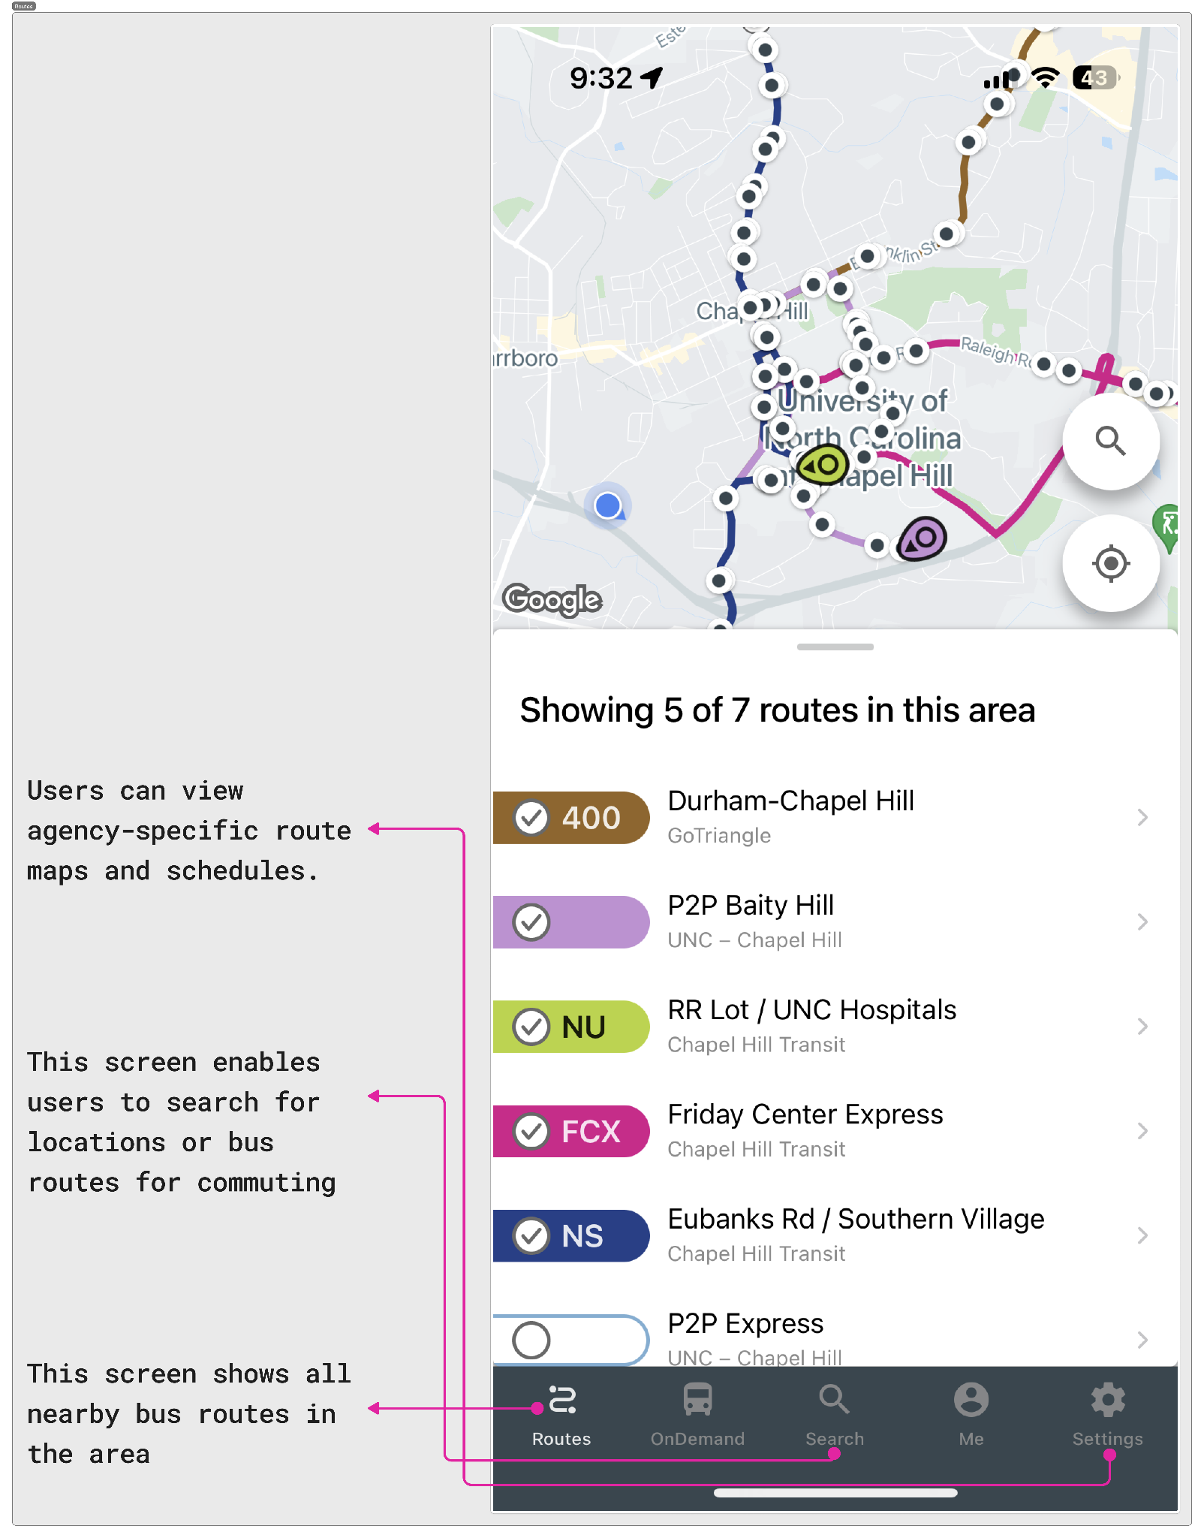 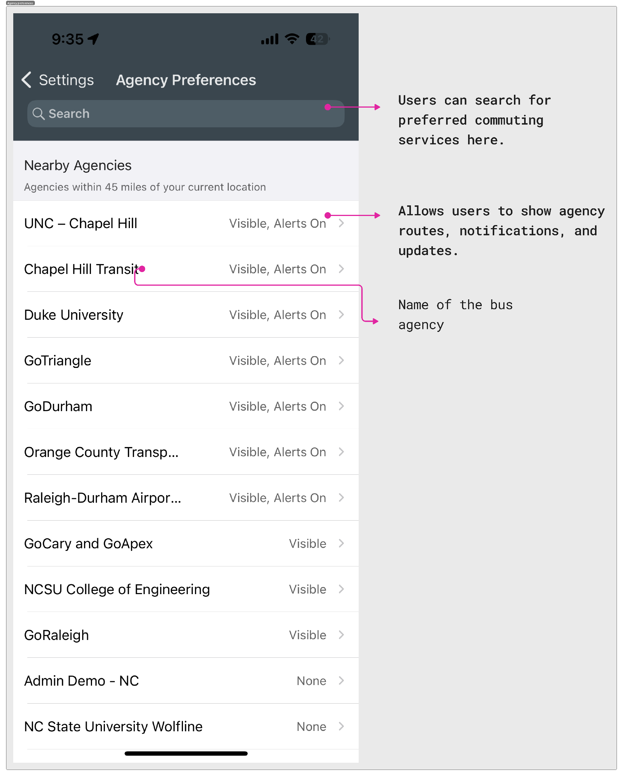

*Screenshots from TransLoc Mobile Application*

# Evaluation Goals

After our evaluation, we hope to answer the following questions as they apply to the TransLoc Application:

* Are users able to understand how to plan single-route trips?
* Are users able to understand how to plan multi-route trips?
* Can users add or remove route providers successfully using the “settings” tab?
* How long does it take a new user to plan a route for a future time?
* Can a user identify the exact time a bus will arrive at their stop?

## Considerations

The goals for our evaluation include examining the “routes” tab in the Transloc app. We will be evaluating how to plan single-route trips, multi-route trips, how simple it is to determine the best route to take to a particular location, and how clearly pickup and dropoff times are listed. Additionally, the Chapel Hill bus routes will be reinstalling GPS units for live tracking. We hope to also evaluate the difference that these new units will make in the accuracy and usefulness of the TransLoc app. Finally, we will be evaluating the settings tab in the TransLoc app by assessing the available route services, attempting to toggle the correct routes to go to different areas around North Carolina, and assess how the settings page follows typical standards and heuristics for these types of applications.

## Extra Features

The TransLoc App also offered “On-Demand” rideshare services along with a web version of its app. While these services are important and very useful, we will not be evaluating them for the purposes of this project due to their contrast to the “routes” tab and to keep the scope of our project focused.

# Users

1. **User Class:** Fixed-Route Commuter
2. **Background:** Anyone who works at UNC Chapel Hill. In general, these people will be using the TransLoc system to travel to and from campus on a semi-consistent basis. They will be using the same route around the same times each day of the week.
3. **Goals:** To get to campus on time consistently. They rely on bus tracking apps to determine which bus will get them to campus most efficiently while still being on time, and make sure there is availability for the bus they need.
4. **User of Similar Application:** People might use other bus tracking apps, including NextBus or Google Maps.
5. **User Class:** Variable-Route Travelers
   1. **Background:** This commuter is someone within the Chapel Hill community. They use the bus system regularly, but might not always use a consistent route or time. They need public transportation to get around, and go to wider areas of the community including grocery stores, rec centers, and restaurants. They are familiar with the area, and have used buses consistently for a while.
   2. **Goals:** Their goals are to get to where they need to go. Time and punctuality are not always as important to this user group, instead, they value consistency, reliability, and accessibility.
   3. **User of Similar Application:** Community travelers might use other applications such as Uber, Google Maps, or hard copy of routes and times.
6. **User Class:** Tourists
7. **Background:** A tourist is someone who is visiting and using the bus for the first time. They may be unfamiliar with the app as a whole, or just the specific routes in Chapel Hill. They do not know street names, or where places are. They might be traveling to campus, or through the wider community. They also do not have someone helping them use the app.
8. **Goals:** In general, they are looking for the easiest and most convenient way to visit the city, while keeping cost in mind. Their goals revolve around convenience. They are not in town for very long, and want to visit many different places.
9. **User of Similar Application:** Tourists might use apps such as Uber, Google Map, or they might rent a car. Some tourists might be familiar with other public transportation apps from their hometown, like OneBusAway.
10. We have classmates who have never used TransLoc before and are also new to areas in North Carolina and its public transport system.

# Tasks

1. **Task**: A student needs to travel from their house in Carrboro to campus for their in person lab using public transportation. This class recurs weekly, so they are looking for the quickest, easiest, and most reliable bus route to use to take them to class.
   1. **Using the interface**: Using the TransLoc app, the student could browse available bus routes in the “Routes” tab, available routes are shown based on which transit lines the user has toggled in their settings, or they could search for specific starting and ending locations in the “Search” tab. They will use these features to compare route times and lengths to determine which route would be the best for their situation.
   2. **Potential problems**: The biggest potential problems related to this task are general usage issues. The student might struggle with the usability of the app, complicating their task. The student might also have difficulty finding a route or determining if that route is recurring weekly at the same time for their class. These problems are of moderate severity because they occur fairly frequently, but could be easy for the user to overcome.
2. **Task**: A community traveler has to stay late at work on Franklin Street and will not get off until 10:00pm. They live a few miles from Franklin Street and need to find a bus route that can take them home, but they are unsure which, if any, routes run that late at night.
   1. **Using the interface**: Using the TransLoc app, the community traveler can use the “Search” tab to look ahead to when their shift ends to see what bus routes are available. They could also use the “Routes” tab to select specific routes that travel between Franklin Street and where they live, and look at the specific times it is scheduled to run.
   2. **Potential problems**: Because the app does not currently support live tracking and buses do not run as frequently at night, a potential problem is that the community traveler misses their bus because the times listed on the app were not accurate. The current TransLoc app assumes a consistent schedule from the Chapel-Hill Transit system, but does not correct for a lack of drivers or available buses on any particular day. They may wait hours for the next bus.
3. **Task**: A community traveler wants to take a trip from Chapel Hill to Asheville solely using public transportation. They know that they will most likely have to switch bus routes to get to their final destination, and want to use the app to schedule their trip and make sure that switching routes is time efficient and easy.
   1. **Using the interface**: Using the TransLoc app, the community traveler could compare all available routes and bus services offered in the app. They could also use the “Search” feature to help them build a series of routes that allows them to reach their destination.
   2. **Potential problems**: One potential problem the community traveler might encounter is general UI issues related to the capability of the app to combine multiple bus routes into one trip. Similarly, while traveling through different areas of the state, they may lose service and not be able to access the app. Finally, because this trip entails moving from bus to bus and the app lacks real-time tracking, the community traveler might miss one of the bus transfers and not be able to continue on their planned route. This issue is severe because although it may not be as common, it would be very difficult for the user to overcome.

# Methodology

This usability study will gather assessment data about the effectiveness and intuitiveness of TransLoc application. We will also gather data on how familiar participants are with the TransLoc App, how familiar they are with the Triangle Region/ North Carolina, and how familiar with the public transit system. Participants will fall into three groups by the starting point they use to perform the tasks while thinking-aloud. We will directly observe and collect data about error and success rates, quantify the participants’ performance, and qualitative data about participants’ experiences using the App.

## Test Environment

We’ll use a controlled setting to conduct the sessions. The study will take place in the classroom at Manning Hall. There will be a room with only the test participant and the team. We will have 1 moderator, 2 observers, and 1 scribe in the room conducting each session.

## Test Equipment and Material

Participants will use an iPhone with high-speed connection to the Internet. Participants will interact with the Transloc app that has been installed and set up properly on the iPhone. One of the observers will be in charge of another iPhone for audio recording. The audio recording will capture the participant’s think-aloud and their interaction with the moderator. The moderator will have paper copies of the test materials. The scribe will have a laptop to take notes. One observer will have a paper copy of test materials and data collection forms for backups.

## Task list and descriptions to be given to participants

**Task 1 (Happy Task)**: Imagine you are a student at a university. You are familiar with the layout of campus and the surrounding community, and have used public transportation in the past. You need to get from Weaver Street Market in Carrboro, NC to your class in Phillips Hall on UNC’s campus. Your class is on Monday at 1:30pm. Using the TransLoc app, find the quickest, easiest, and most reliable bus route to take you from the market in Carrboro to UNC’s campus for your class.

**Task 2**: Imagine you are a community member who works on Franklin Street, Chapel Hill, NC. You unexpectedly have to stay late at work one night and will not get off until 10:00pm. You live a few miles from Franklin Street and need to find a bus route that can take you to the University Place Mall in Chapel Hill, NC, from which you can walk home. You are unsure which, if any, routes run that late at night. Using the TransLoc app, show me how you would find a bus route to take you from Franklin Street to a bus stop at the University Place Mall when your shift ends at 10:00pm.

**Task 3**: Imagine you are a member of the community wanting to visit a friend in Asheville, NC solely using public transportation. You know that you will most likely have to take multiple different routes to reach your final destination. Using the TransLoc app, show me how you would schedule your trip from UNC’s campus in Chapel Hill, NC to UNC Asheville’s campus in Asheville, NC. Try and make sure that switching routes is time efficient and easy.

## Session Outline

**Pre-test arrangements (5 minutes)**

Have the participant:

* Review and sign nondisclosures and recording permissions.
* Fill out a questionnaire to understand participant’s prior experience with TransLoc and how familiar they are with TransLoc.

**Tasks (30 minutes)**

Participants will perform 1-3 tasks on TransLoc in the test environment.

**Post-Task Questionnaire (After each task)**

Participants will answer 3 broad questions to collect preference and other qualitative data.

**Post-test survey (3 minutes)**

Follow up on any particular problems that came up for the participant.

**Roles**

| **Role** | **Duty** | **Number** |
| --- | --- | --- |
| Moderator | Moderate session | 1 |
| Scribe | Collect the participant’s answer during session | 1 |
| Observer | - Collect data on how participants interact with the app during session  - Serve as a backup and assistant for moderator  - Control audio recording | 1-2 |
| Scheduler | Primary contact for participants | 1 |

# Data Collection

The data that will be collected in the study includes both qualitative and quantitative information. The qualitative data in this study aims to understand participants’ experience with the app in terms of natural language feedback, including comments about the tasks as indicated in the scribe’s comment boxes in the moderator script included later in this document; noting when participants require assistance to complete tasks; and a think-aloud narrative provided by each participant as they progress through the test. Think-alouds will be recorded with a mobile audio recording app by the moderator and transcribed from audio to text, either manually using a word processor or with the aid of an automated, secure transcribing service such as Transcribe. Quantitative data to be collected in the course of the study includes success/fail rates across all participants computed as a percentile and time-to-completion for each participant in the format of MM:SS.

In efforts to evenly weight participant experience across mixed methods data collection, the Transloc team will employ both numerical scales and natural language formats for participants to report their feedback to the research team. The moderator guide includes 1-5 scales for a pre-task questionnaire regarding familiarity with the Transloc interface and post-task questionnaires on participants’ ease of completion. Each instance of a scale is followed by space for comments in the format of natural language so that participants may explicate a more nuanced, but brief, reflection of their experiences at checkpoints throughout the test. The success/fail rate and time-to-completion information will be tracked in a spreadsheet where each participant is a column and each datapoint is a row so that the team may aggregate numerical data across the study in one location for later analysis.

Participants of the study are entitled to full privacy and anonymity. Participants will never be asked to provide self-identifying information such as personal or workplace addresses. Further efforts to protect participant privacy and confidentiality include adhering to all IRB procedures for research with human subjects as outlined in the CITI training. Survey and questionnaire feedback from participants will be collected using Qualtrics. Data collected as part of this research will be stored in a shared drive that only team members have permissions to access. All personal machines used by team members have password-protected and encrypted hard drives.

# Evaluation Measures & Metrics

With the goal of compiling both qualitative and quantitative data to understand the overall effectiveness of the TransLoc application and answer our evaluation questions mentioned in the evaluation goals section, we will be measuring both the perceived success of the participant and the actual task success.

## Qualitative Metrics

* User Satisfaction: measured on a 1-5 scale where 1 is unsatisfactory and 5 is satisfactory.
* User Familiarity: measured per task to compare relatively against errors and user satisfaction metrics. Less familiar users will often encounter more errors and have less satisfactory experiences with any application. It is important to adjust for this.
* Ease of completion: measured on a 1-5 scale where 1 is very easy and 5 is very difficult.
* Observed ease of completion: test observers rating on the same 1-5 scale where 1 is very easy and 5 is very difficult.

## Quantitative Metrics

* Task Success: measured as 0 if the task was incomplete and measured as 1 if complete.
* Errors: measured as the number of errors encountered throughout the task process. This is to measure the amount of hiccups users run into attempting tasks.
* Time to completion: measured as the time between the user beginning their task and either completing or giving up the task.

# Moderator Guide

## Written Moderator Script

Hello, my name is _____ and welcome to our usability test. Thank you for joining. Today, we are going to be using the TransLoc app to complete a series of tasks. TransLoc is a transportation application designed to help customers find fixed-route and on-demand services that meet their needs. This test will take approximately 45 minutes to one hour and you will be completing a series of 3 tasks. After completing each task, you will answer a few questions regarding that task. At the end of the test session, we invite you to complete a post-test questionnaire. It will only take a few minutes.

During the testing session, we would like you to think aloud. While using the TransLoc app, please verbalize your thoughts and feelings. Speak freely about how the system makes you feel, why you make certain choices, and your thought process along the way. Please also note any questions you have or anything you may be confused about.

During our test, we will not be testing you, only the TransLoc application with the purpose of improving its usability. Please provide honest feedback and do not feel bad if you cannot complete a task or have questions. Again, the purpose of this test is to see how our users interact with the application. Your performance will not be tested and there are no right or wrong answers.

With your permission, we will be audio recording the session. This recording will not contain any information outside of what you verbalize during the session, and will only be used to improve the usability of the TransLoc app. Can you please confirm permission to record this session?

*[Circle participant’s audio recording permissions below]*

| Participant consents to audio recording of testing session:  Yes No |
| --- |

Before we begin, please fill out the following pre-task survey. Your answers will remain anonymous, so please answer them honestly.

*[Hand tester pre-task survey (paper version and pencil, link/QR code, etc.) and wait for them to fill it out]*

Do you have any questions before we begin?

*[Being audio recording of session]*

Now we will move into our tasks for the testing session. Remember, please think aloud while completing each task.

*[Hand tester a smartphone to with the TransLoc app open to the home screen}*

Task 1: Imagine you are a student at a university. You are familiar with the layout of campus and the surrounding community, and have used public transportation in the past. You need to get from Weaver Street Market in Carrboro, NC to your class in Phillips Hall on UNC’s campus. Your class is on Monday at 1:30pm. Using the TransLoc app, find the quickest, easiest, and most reliable bus route to take you from the market in Carrboro to UNC’s campus for your class.

*[Record notes from this task below]*

Notes

|  |
| --- |

Thank you for completing the first task. I will now ask you a series of questions regarding the task, please answer honestly.

*[Record the tester’s answers to the following questions]*

1. On a scale from 1 to 5, with one being very difficult and five being very easy, how easy or hard did you find this task?

| Very difficult |  |  |  | Very easy |
| --- | --- | --- | --- | --- |
| 1 | 2 | 3 | 4 | 5 |

Comments

|  |
| --- |

1. What did you like about the process of completing this task using the TransLoc app?

Comments

|  |
| --- |

1. What would you change about this process?

Comments

|  |
| --- |

Thank you for completing the first task. We will now move on to the next task. Do you have any questions before we proceed?

Task 2: Imagine you are a community member who works on Franklin Street, Chapel Hill, NC. You unexpectedly have to stay late at work one night and will not get off until 10:00pm. You live a few miles from Franklin Street and need to find a bus route that can take you to the University Place Mall in Chapel Hill, NC, from which you can walk home. You are unsure which, if any, routes run that late at night. Using the TransLoc app, show me how you would find a bus route to take you from Franklin Street to a bus stop at the University Place Mall when your shift ends at 10:00pm.

*[Record notes from this task below]*

Notes

|  |
| --- |

Thank you for completing the second task. I will now ask you a series of questions regarding the task, please answer honestly.

*[Record the tester’s answers to the following questions]*

1. On a scale from 1 to 5, with one being very difficult and five being very easy, how easy or hard did you find this task?

| Very difficult |  |  |  | Very easy |
| --- | --- | --- | --- | --- |
| 1 | 2 | 3 | 4 | 5 |

Comments

|  |
| --- |

1. What did you like about the process of completing this task using the TransLoc app?

Comments

|  |
| --- |

1. What would you change about this process?

Comments

|  |
| --- |

Thank you for completing the second task. We will now move on to the next task. Do you have any questions before we proceed?

Task 3: Imagine you are a member of the community wanting to visit a friend in Asheville, NC solely using public transportation. You know that you will most likely have to take multiple different routes to reach your final destination. Using the TransLoc app, show me how you would schedule your trip from UNC’s campus in Chapel Hill, NC to UNC Asheville’s campus in Asheville, NC. Try and make sure that switching routes is time efficient and easy.

*[Record notes from this task below]*

Notes

|  |
| --- |

Thank you for completing the third task. I will now ask you a series of questions regarding the task, please answer honestly.

*[Record the tester’s answers to the following questions]*

1. On a scale from 1 to 5, with one being very difficult and five being very easy, how easy or hard did you find this task?

| Very difficult |  |  |  | Very easy |
| --- | --- | --- | --- | --- |
| 1 | 2 | 3 | 4 | 5 |

Comments

|  |
| --- |

1. What did you like about the process of completing this task using the TransLoc app?

Comments

|  |
| --- |

1. What would you change about this process?

Comments

|  |
| --- |

Thank you for completing the last task. Do you have any final thoughts, questions, or concerns about the TransLoc app you would like to share?

*[Record any notes below]*

Comments

|  |
| --- |

Great! Thank you again for taking the time to complete this usability test. Your insight will help us improve the TransLoc app, we appreciate your help. Before you leave, please fill out the post-test survey. It will only take a few minutes.

*[Hand tester pre-task survey (paper version and pencil, link/QR code, etc.) and wait for them to fill it out]*

Thank you again for your cooperation and assistance today. Have a nice day!

*[End audio recording of session]*

## [Pre-Test Questionnaire](https://unc.az1.qualtrics.com/jfe/preview/previewId/62ea4e8a-fbf4-4df1-a1d8-aafb7166be89/SV_9HKVeJYVD6ZJufQ?Q_CHL=preview&Q_SurveyVersionID=current) – Link

***List of Pre Questionnaires:***

1. What is your age group?
2. What gender do you identify with?
3. Have you ever traveled by public transportation? In that case, kindly share your experience.
4. Have you ever used a public transportation app? If so, list them.
5. Are you familiar with the Transloc app?
6. How frequently do you take public transit?
7. How effective is public transportation for you?
8. Do you usually organize your trips using public transportation?
9. Would a public transportation app change the way you utilize public transportation services?
10. How familiar are you with the Chapel Hill, Durham and Raleigh area?
11. If a public transportation app existed, what features would you require?

## [Post-Test Questionnaire](https://unc.az1.qualtrics.com/jfe/preview/previewId/435a10b9-038e-4688-84d7-09b910480a9b/SV_cTo6s8fPwC4icvA?Q_CHL=preview&Q_SurveyVersionID=current) – Link

***List of Post Questionnaires:***

1. Did you find it simple to use the Transloc app?
2. Did you find the Transloc app to be useful when organizing your trips on the public transit system?
3. Did you experience any issues with the Transloc app's functionality?
4. Did the Transloc app enhance your overall experience using public transportation?
5. Do you think other people should download the Transloc app?
6. Will you keep using the Transloc app in the future?
7. What changes do you think the Transloc app needs? Are there any features that you think should be improved or added?
8. Did you receive what you expected from the Transloc app?
9. Do you have any further feedback or remarks regarding the Transloc app? Was there anything in particular about the app that you liked or didn't like?
10. Did the app provide clear and accurate information about bus schedules and routes?
11. Did using the app make you feel confident and ready for your trip?
12. Did your bus route experience any unforeseen changes or delays while you were traveling?